John B did a presentation about a legal case – Rylands verses Fletcher – and which started at the old finishing mill on Bury Road (near Taylor’s Lane) and which went on to be used to resolve cases both in this country and in the English speaking world.
In 1860, John Rylands, who owned the finishing mill, employed contractors to build a reservoir on the north side of the mill. The contractors started digging and found the remains of some old mine shafts but, rather than abandon the work, they filled in the holes with rubble and continued with the construction. The reservoir was filled and inevitably the water quickly washed away the rubble and within ten days the water entered the mines, flooding the Redhouse Colliery Coal mine, owned by Fletcher.
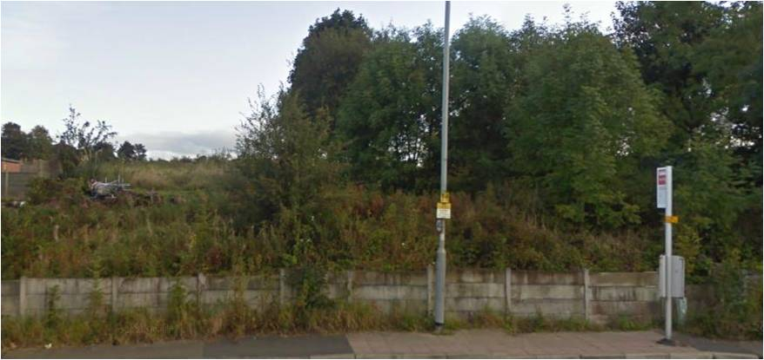
Understandably, Fletcher sued for damages (about half a million pounds in today’s money) and the case went all the way to the House of Lords, who ruled in Fletcher’s favour and this ruling has been used to claim damages in the Three Mile Island Nuclear disaster, the Exxon Valdarz disaster and the New Orleans flood, to name just three. So Ainsworth became the place of a landmark legal judgement.

Polly show the updated website and a number of old photos, brought by people at the meeting, were passed around

