With about thirty people attending, our October meeting started with Anne Rule describing the history of Guiding in Ainsworth. The presentation started with a photo of the original unit, which existed in the late 1930’s and closed in 1950. There is no evidence of it being registered with the Guide association, but when the new unit was formed in 1957, the old flag, with Radcliffe 12th on it, was found, suggesting that there was a unit but that the paperwork had been lost. The original unit went on camp in 1943, using public transport to get to their campsite in Wales and carrying the bedding in brown paper parcels tied up with string – quite a journey in war time.

In 1957 the new unit was formed and Anne showed a number of photos of guides from that date until the present time of camps (including one where the group used a flag which belonged to the Guider’s mother and had been flown on VE day), Whit Walks, visits, guards of honours at weddings, parties and reunions for the 40th and 50th anniversaries. A number of those present recognised themselves or other friends and relatives.
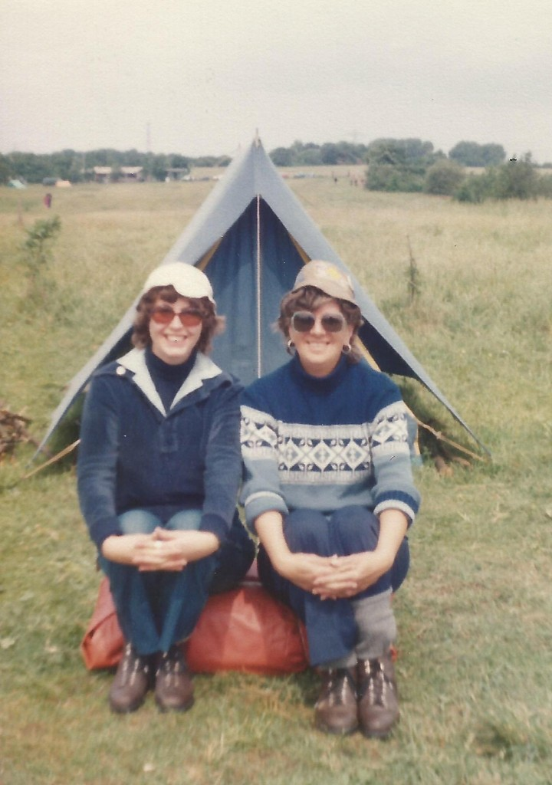
Anne and Laura at Giant's Seat camp in 1980
Steve H then showed a DVD of the 1980 Village Day, which took place off Arthur Lane. The original cine-film was taken by George Parker and Steve had transferred it to DVD and had added some very entertaining music and sound effects.
The meeting ended with a series of photos from the archive on the theme of “Farms”

