There were two presentations in the March meeting – at opposite ends of the spectrum!!.
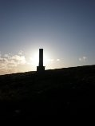
Holcombe Hill
Dave C showed photos of some of the places (such as Holcombe Tower, Scout Moor windfarm, Oldham, Saddleworth Moor, Ringway Airport, Joderall bank, Helsby Hill, Molefamau, Fiddlers Ferry power station and Winter Hill Mast), that could be seen from in and around Ainsworth. Some of these could be seen with the naked eye and others with binoculars.
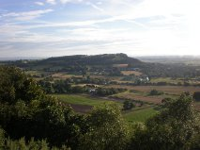
Helsby Hill
We were amazed at just how far could be viewed from the top of the hill behind the village (Bentley Hall Lane) – providing it was a clear day!
Then much much closer to home, we were told about concealed shoes which were found just a few doors away in Church Street. Alison provided a description of how the shoes were found and photos of them and also the report from Northampton Museum about the shoes.
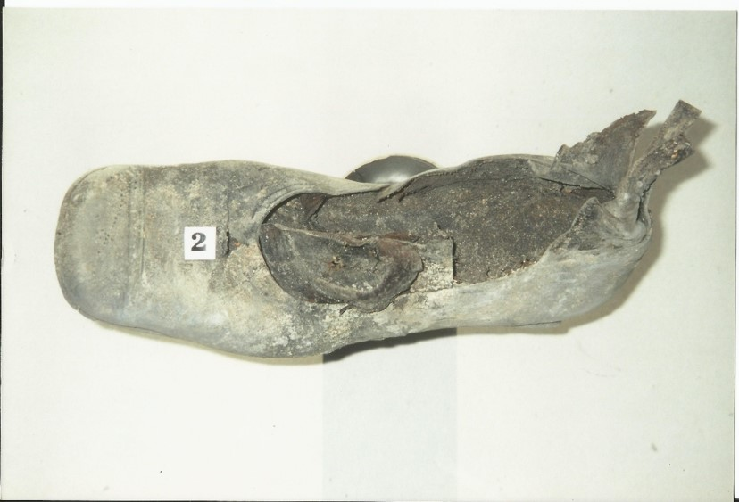
This was also the source of more information about concealed shoes. A fuller account of this is on our website
The meeting ended with a reading from Ken Bullock’s book, about the village’s connection with the Von Trapp family, chosen by Sheila following the death of Maria Von Trapp

