Polly started the meeting with some photos from the archive of villagers from the 1900’s to the recent past, including some stories connected with them
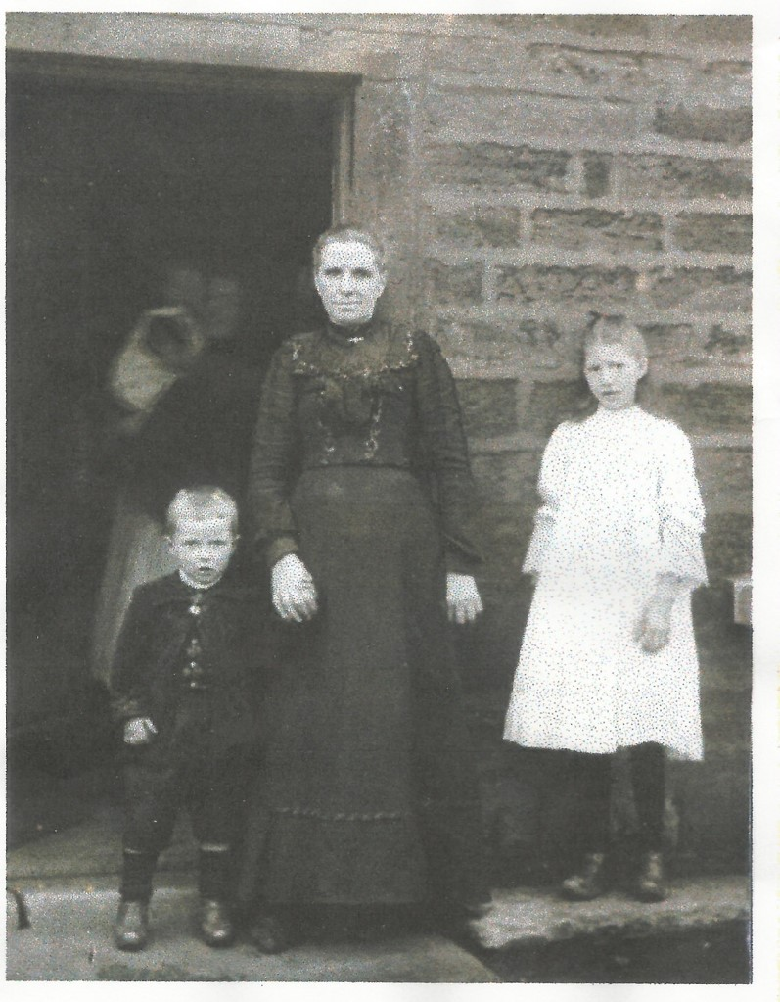
Gail did her talk on “Edible Ainsworth”, which had been postponed from April. Following a reminder about the care needed in picking the plants (especially avoiding dog walking areas! and making sure that the landowners permission is obtained where appropriate), she focused on the plants which could be found on the short stretch of hedgerow on Knowsley Road, going towards the Nursing Home.

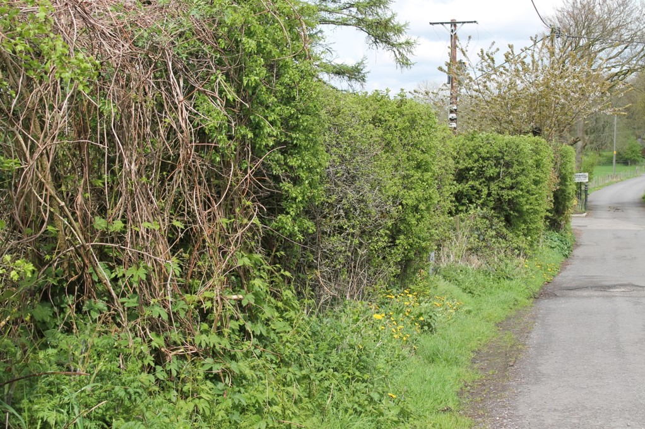
There in Spring and Summer can be found Dandelion, Nettles, Hawthorn leaves, Water mint, Wild garlic, Sweet Cicely, Wood Sorrell, Sorrell, Jack by the hedge, (garlic mustard), Sticky Willy (Cleaver), Bistort and Beech leaves; and in Autumn, Hops, Rosehips, Blackberries, Sloe, Elderberry and Hawthorn
She then treated us all to nettle pesto on crackers – which, despite some initial concerns, turned out to be very tasty indeed

