In what seems to be a regular occurrence now, over thirty members braved torrential rain to attend the meeting!
Thanks to research by Steve, there was a real insight into the involvement of local people in the Great War. He showed photographs, grave records and other documentation about three in particular – Daniel Brooks, Harold Hamer and Edgar Wilkinson. The First World War can seem like ancient history until a photograph is shown and someone says “That’s my dad”. When Hilda said that, it brought home how recent and real the First World War was - how it did touch the lives of, not just local people, but most communities in Britain. Particularly moving was a letter sent by Daniel Brooks to his sister just a few weeks before he was killed on New Year’s Eve. Jack had also provide a photo of his uncle, who served in the First World War, and the lucky escape he had – saved by a flak jacket bought for him by his wife’s family.
Laura read a piece from Ken’s book of the postmaster’s account of life in the village at that time “from Peace to War”
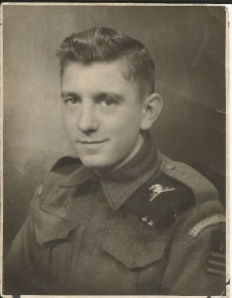
Then Jack, aided by his son, gave a moving account of the journey of his brother, Billy Barlow, from when he landed in France in July 1944 and we heard how luck was initially with him, only to run out six weeks later when he was killed liberating a small village in the Netherlands, It was very touching to see Jack still in touch with a Dutch Lady who tends his brother’s grave in the Netherlands

There are articles on both World War 1 and Billy Barlow in the "memories" section of this website

