The meeting started with some village news and some archive photos of workers in Ainsworth, from the turn of the 20th century to its end.
Then Nigel gave a presentation on the Whitehead Lodges, the bottom lodge probably being built originally for an old corn mill and then used by a print works (fabric not paper). This was followed later by the middle and top lodge, built by John Whitehead, who owned several local businesses and properties. The lodges were largely hand built with row after row of local stone used to line them.
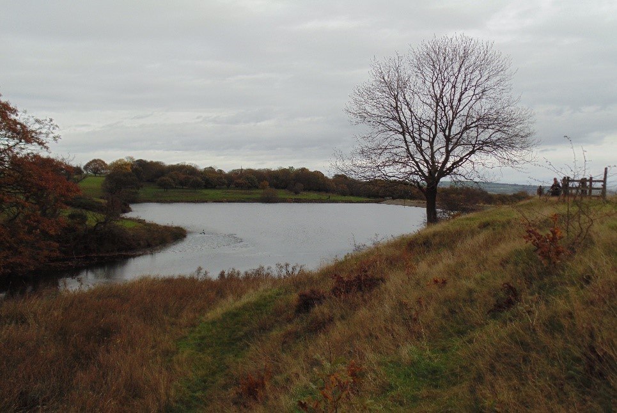
Middle Lodge, which was breached after heavy rain
He also gave some information about the heavy rain in late November/early December 1852, which led to middle lodge being breached at 7am on Sunday 5th December with the water flowing into the bottom lodge and, although the water was briefly checked there, it too was soon breached. It flooded the Dye works and picked up a four tonne wagon, narrowly missing the base of one of the chimneys. It caused other damage in its wake and when it reached the Bolton-Bury canal, picked up several barges – dumping one on the tow path. The disaster was reported in both the Manchester Guardian and London News, with a wooden engraving of the scene.
The presentation was then followed by photos from the archive of the lodges in snow and of children playing on the bridge at the middle lodge`.
Following this, Sheila read a piece by Walter Taylor entitled 'The Old Lodge' about some of the escapades that happened in the 1920s in what is now The Delph

Steve showed two DVD’s – one of the making of Hurricanes at Longridge and one of Village Day in 1980

