Once again, there was a good turnout for the meeting. Steve H showed us a copy of the Church magazine from July 1945. Although it contained a number of articles not related to the village,it was fascinating to see the adverts, especially the one from the coal merchant who promised "I can make it hot for you
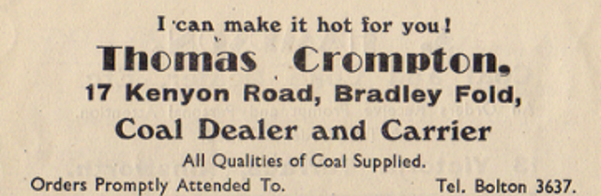
" – and some of those present remembered the shops and services mentioned.
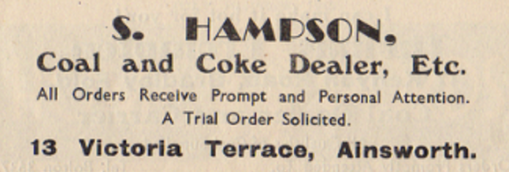
He also showed a number of pictures of the area around the Unitarian church.
Dave C told us about the successful visit which some of the members of the History Society had made to Heaton Park which was owned by the Earl of Wilton, who also owned land in the village.
Then Steve entertained the group by showing two videos – one of a car driving around Bury in 1961, before the re-development of the town centre, and another, with commentary, filmed in 1969 showing the demolition of buildings to make way for the Millgate centre and the temporary building erected following the fire that destroyed Bury Indoor Market. Once the new market had been constructed and opened, the temporary market building was purchased by Smith & Cooke and re-erected in the village on the Moorside Mill site. It is still there and in use at the present time.

