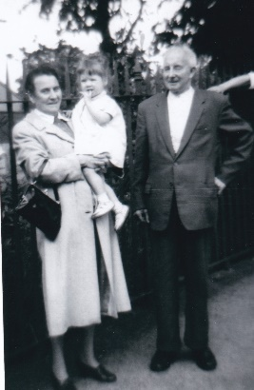
After sharing village news, we looked at some photos which had been brought to the meeting by the group members and a photo of Church Street at the turn of the 20th century
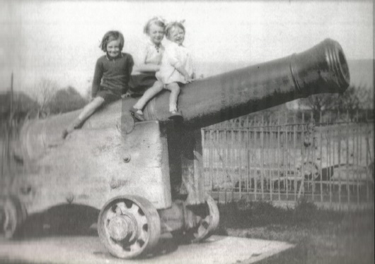

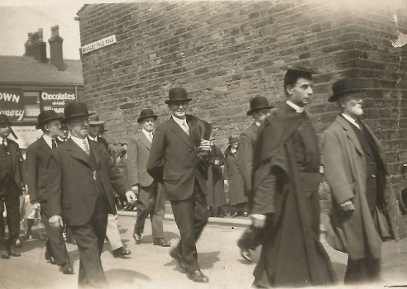
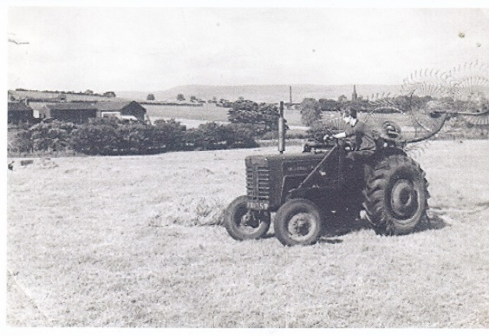
Then we looked at a number of photographs of villagers from the 1890 to the present day. Those present at the meeting added to our knowledge of the photos by naming some of those featured and by giving snippets of information about the village at various times in the past.

