A well-attended meeting heard the first part of the “Cockey Moor in World War 2” presentation (with part 2 in July) and which can also be found on our website.
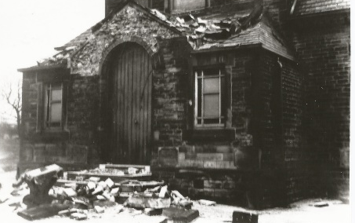
The meeting started with an overview of events in the war years, based on information from Ken Bullock’s book. We learned that during the summer holidays of 1939, air raid shelters were erected, three evacuees were admitted to the village school and that the village band broke up. We heard about the deep snow in 1940, where the drifts were almost up to the top of lamp posts and that soldiers from the army camp had to dig out the village. In 1943 a severe gale cause damage to the front of the Methodist church and in 1944, 2 Well Street was sold to the Conservative club and pantos were performed in the church hall. 1945 brought the end of the war with children having a day off school for VE day (and the VJ day)

Hilda then recalled her life as a young girl in the war – remembering that the day war was declared In September, she was due to go to Stand Grammar, but this had to be postponed as the air raid shelters had not yet been built at the school. Air Raid shelters were built in the back streets for each road. The siren was on the top of the church and as Hilda lived close by on Bradley Fold Road it was very loud when sounded. Every week there were practices at school in using the gas mask. Despite all this, she never remembers being afraid during the war.

She also mentioned that the pay corps was situated in Radcliffe and that soldiers were billeted with anyone who had a spare bedroom and so there were quite a lot of the soldiers in Ainsworth. This led to a number of romances - and a society member mentioned that her sister married a soldier who was billeted in Victoria Terrace. Hilda also talked about the black out - that there were no street lights at night and that buses finished running in the early evening. She told us of food rationing, the lack of imported fruit and of allotments at the top of Starling Road.
(a full version of Hilda’s talk is on our website)

Jack gave a repeat talk on his brother Billy’s journey through France and Belgium, from his landing at Juno beach just after D Day to his death at Vessem in 1944. We also watched a short video of his recent journey back to Vessem where his brother is buried.

After a short break, we saw some photos of Bankfield, which a society member had brought with him, and Hilda recalled how it was a private school during the war, with a number of children, whose fathers were serving abroad, being boarded there. She remembers going at Christmas with the Air Raid Wardens and others to sing carols to the children, who sat around in their dressing gowns and pyjamas.

