Ainsworth Village History Society www.ainsworthhistorysociety.org

We meet on the Second Tuesday of each month from 8:00pm at the Old White Horse on Church Street – next meeting 12th January.

Archive:
We have set up an archive and photos are now on our sister website (see above) If you have any photos relating to the village, please, contact Polly at the Vicarage (01204 398567) to make arrangements for them to be scanned. There is a display board in the library, on which photos and other information is shown

November Meeting
The group shared “Memories of the Bradley Fold Road Area” (postponed from October). Bradley Fold Road was once known as Schoolside as there was a school on the east side of the road, opposite the area known as “The Ankey” (Anthony Fields). Henry Hardman was the master there for 20 years until 1785 and Abraham Hardman took over and was master for 40 years!

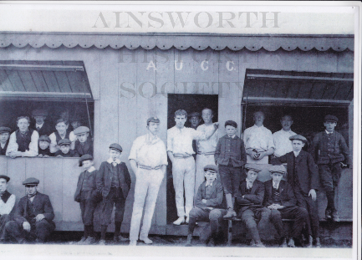
It was on Schoolside that Hilda was born. Hilda has clear memories of Schoolside and these were shared with the group. There was a lively discussion when three maps were shown, one from 1838 which showed the old school; one from 1930, before the Devon Drive and Broomfield estates were built and which showed the football and cricket grounds; and one showing the area as it is now.

David also gave us some of his memories of life on Bradley Fold Road and some information about relatives at Rothwells (on the lane between Bradley Fold Road and Ainsworth Hall Road).

We discussed the three doctors’ surgeries which were held in the village – in the front rooms of houses on Bradley Fold Road and Church Street, with the kitchens being used as the waiting room

(a copy of the presentation is available on our website)

