Coal Mining

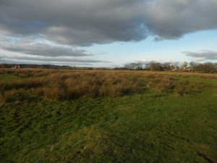

The Cockey Moor Coalfield
A relatively unknown coalfield possibly dating back to the medieval period
Local Historian, Ken Howarth describes this view as The ancient lost landscape of Cockey Moor. A relatively unknown coalfield possibly dating back to the medieval period
The site itself is bounded by Cockey Moor Rd. to the north, Higher Pit Lane to the south, Starling Rd. to the east and Sumner Ave. to the west. An examination of the area reveals evidence of old abandoned bell pits.
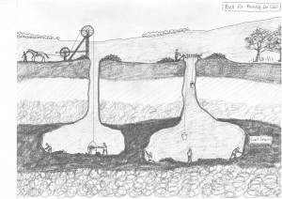
This diagram shows how the bell pit system worked. A shaft was dug until the coal seam was reached. On Cockey Moor it is said to be between ten and fifty feet from the surface. The miners would then excavate around the shaft in all directions. No support was used and the mine was simply abandoned when the risk of collapse became too great. Another pit was then dug nearby with the spoil being thrown into the first pit.
Although it is known that the Romans used coal it is thought that they only dug it from where the coal outcropped at the surface and that the Bell Pit system is the earliest form of proper mining dating back to the medieval period.
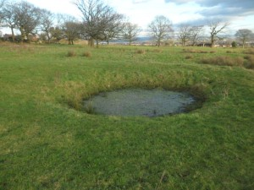
If you take a walk round this site it doesn't take long to find the remains of the Bell Pit shafts
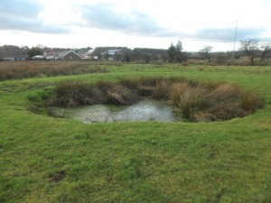
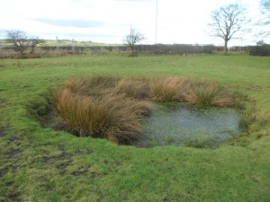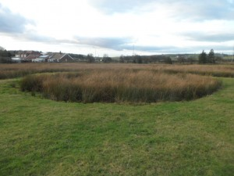
A raised ridge around this shaft indicates the possibility that a horse gin was used
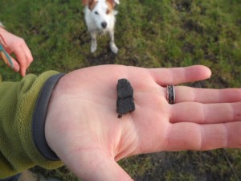
Split coal found on the surface

Cockey Moor Colliery
The junction of Bury/Bolton Rd and Grindsbrook Rd was the site of this once important coal mine. Thought to have been started in the middle of the seventeenth century, the mine followed the coal seam in a north westerly direction until it met the bell pits on Cockey Moor. Unlike the bell pit system this mine was what might be described as a more traditional mine not unlike modern coal mines with a single entrance and the mine being supported as the coal was excavated.

The Cockey Moor Culvert
Flooding has always been a problem in coal mining and the miners on Cockey Moor solved this problem in the 1790's by digging a five foot diameter culvert or sough 200ft down from the surface from the The Cockey Moor Colliery to drain into the river Irwell some two miles away. For more information and a map of the course of this unrecognised feat of civil engineering See Ken Howarth's excellent website at http://g.co/maps/a9ddc
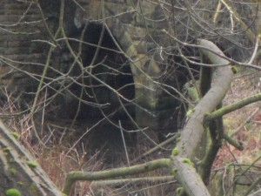
The Cockey Moor Culvert at the river Irwell

Additional information
from David Earnshaw about mining on Cockey Moor:
Whilst looking through the Earl of Wiltons estates I came across a mention of Lamb Well Mine, Cockey Moor Colliery.
I knew there was a mine where Higher Pitt is off Starling Road.

