Walk- 2013 may
Paddock Leach

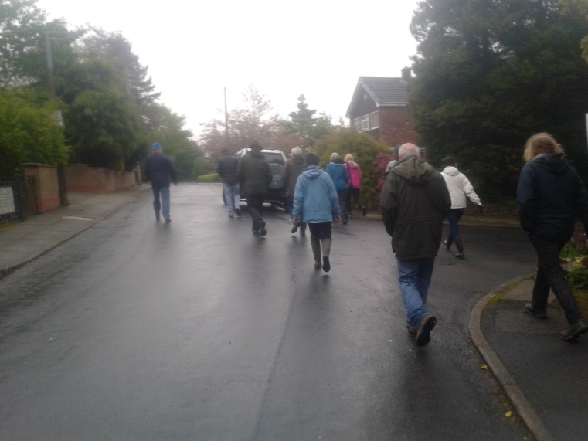
On a very wet Tuesday at 7.00pm, 13 of the more hardy members of Ainsworth Village History Society set out on one of our history walks. This week's topic was Paddock Leach, a 17th century farmhouse with a top floor weaving room which changed to a smallpox hospital and later a nurses' accommodation for the 1906 isolation hospital
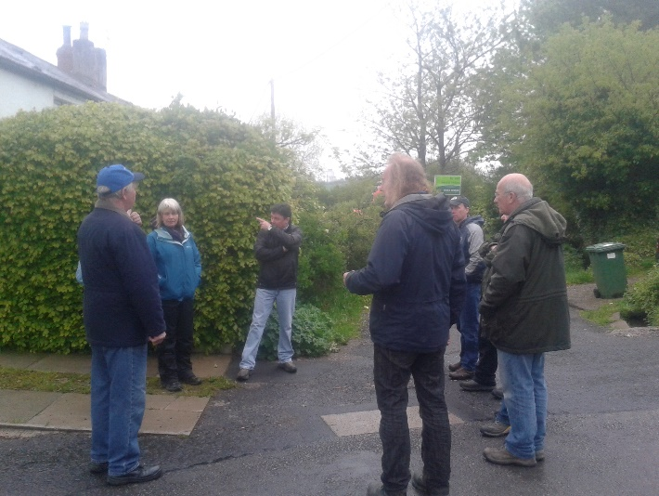
John B had intended to lead this walk, as he knows the current owner of Paddock Leach and had negotiated access for us to view the site, but unfortunately it appeared that he was otherwise engaged, so Dave C gave us a short talk on smallpox, its history and the need for isolation in smallpox cases.
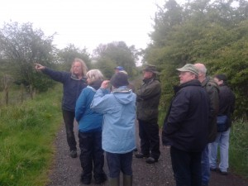
It seems that Paddock Leach was more than just a farmhouse and Tony D gave us some information about some cottages that were associated with the main farmhouse, their location and the names of the residents who lived there in 1838.
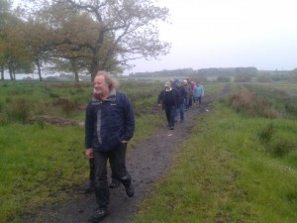
Without access to the Paddock Leach site our trip was somewhat curtailed so we decided to walk along what is known as The Wood Path which leads from Jacksons Lane to Lowercroft Rd. We were fascinated to learn from Steve H that a light gauge railway once ran along this path carrying stone, quarried in Ainsworth, for the construction of Bury Barracks.
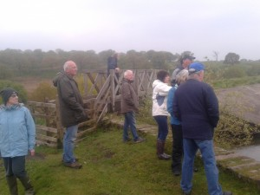
We then made our way over to Whitehead's middle lodge where Dave C told us about the army firing range that was once here and the location of the brass gong that was used as target practice.
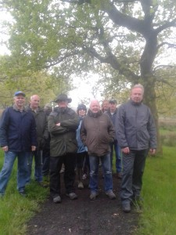
So after an enjoyable couple of hours some of us retired to the White Horse for a well earned beverage where we met John B who had mis-understood the arrangements. Instead of meeting outside the White Horse at 7.00, he was waiting inside and missed us altogether!!

