With about thirty people there, our September meeting started with Steve sharing some photos which showed evidence of gas street lighting in Ainsworth. This was in response to a suggestion from David, in his article on electric lighting (which is the memories section of our website), that there had not been gas street lights in the village.
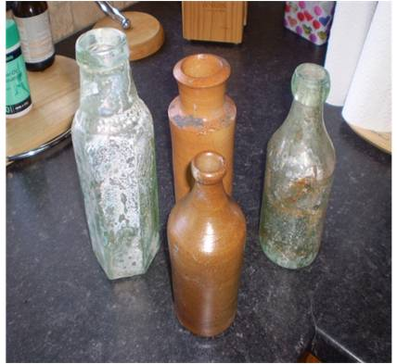
For the main topic of the evening, Nigel spoke to us on the theme of "the history of a house"; detailing his research into his own home on Church Street (full details in the articles section of our website). This was enhanced by other members present, who had more detailed stories about certain aspects of its history - including information from a family who used to live in Ainsworth and who had come because their sister once ran a confectioners at that address.
Nigel also described the excavation of the old steps in the cellar, which used to lead out to the back; unfortunately laying to rest the myth of the tunnel to the chapel but fascinatingly finding over 100 bottles. Sadly most were broken but the four pictured did survive, one being a Blacking Jar (used for blacking fire places and steps) dating from c 1830.
Then Steve, who had been given an old cine film of a history walk from the 1970's, had transferred it onto DVD and we watched it with interest. This was then followed by some further photos from our archive

