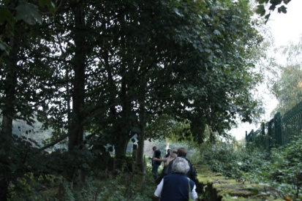
A well attended meeting heard Dave C discuss footpaths in Ainsworth – both the legal definition and the rights of the public to use the footpaths. He showed a number of footpaths on the North side of the village – some unexpected ones and others which we had assumed would be footpaths but were not designated as such. In a number of cases, he gave the historic reason behind the footpath’s existence – almost always as a means to travel to a place of work as walking for pleasure was not really done until recently.

Steve had again edited some of George’s cinefilms – this time of Whit Walks from the 1970’s - and put them onto DVD, with sound.
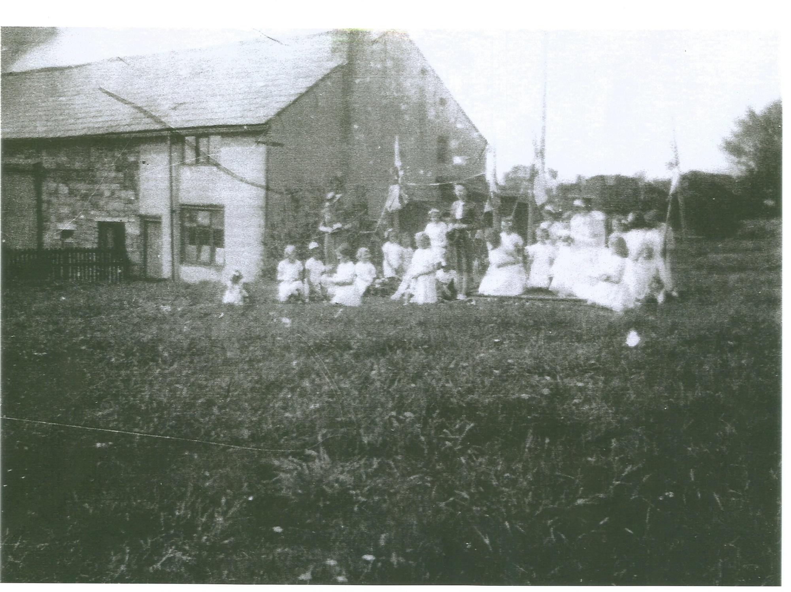
This was followed by some of the photos of other Whit walks, from the turn of the 20th century to its end, which form part of our archive.

Sheila read an extract from the back of Ken’s book – a tale by the Postmaster of the time the first bus came to Ainsworth – and some photos were shown of Ainsworth buses from the 1920’s to the present day

