We had a "share time" when photos were brought and shown, with details and extra information provided by those present. Steve H showed how photos, which we might think were not worth copying, can be enhanced using a computer and some photos he had been given recently for the archive.
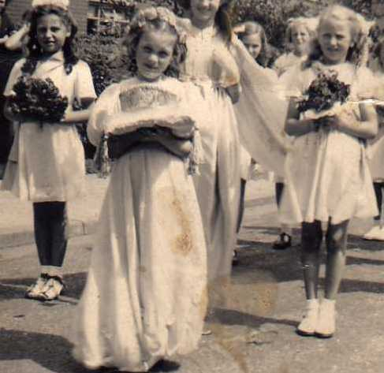
Dave C showed photos of some of the things we had looked at over the last twelve months, including our visits to the Unitarian Chapel and some aspects of the history walks - through the village to the Water Tower; down Knowsley Road to Whiethead Lodges; along the Wood Path to see if we could spot the parakeet and looking at the flora in the area.
