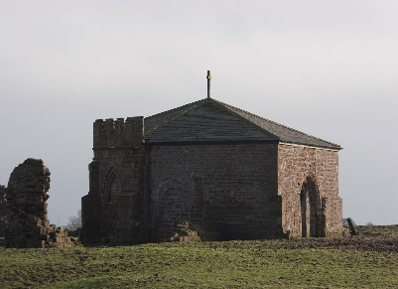
After our AGM, at which the current management committee members were re-elected and where Barry Willcock joined the committee for the first time. Barry then gave us the first part of his very informative talk, looking at what was happening in Britain and other parts of the world, from 1066 to 1515 (when the Church at Cockey was known to exist) and describing the possible consequences for people here in Ainsworth. The first mention of Ainsworth (Aynesworth) appears to be in Great Inquest of Service of 1212, where it is described as part of the Manor of Middleton that was held by Roger de Middleton “for a knight’s fee”, but that it was then part of a parcel of land given by Roger de Myddleton to “God, the Abbot and the Canons” of the Praemonstratensian Abbey of Cockersands, near Lancaster. There was speculation as to whether the name Cockey comes from Cockersands. Since no one at the meeting knew of a mention of Cockey Moor prior to this, it remains unresolved. Barry also looked at other events, including the Crusades and the Black Death and the likely impact this would have had on the villagers here; and at the Mappa Mundi and the limited understanding of the extent of the world.
The remains of Cockersands Abbey

