Once again, the meeting was well-attended and we heard the second part of the “Cockey Moor in World War 2” presentation
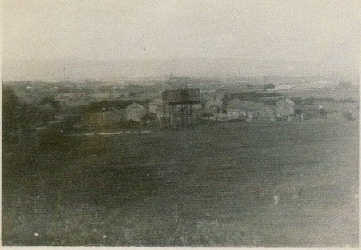
The meeting started by repeating the overview of events in the war years, for those who had missed it in June. This was followed by a presentation of information provided by David Earnshaw about his Uncle, Robert Green, who was killed in the war. Some of those at the meeting, who had been in the village during the war, added to this.
We then heard the memories of Audrey Jennings, who lived in the village during World War 2 and this was followed by information given to us by Roy Turner about the Army Camp at Lowercroft.
(these are all on our website)

Ray had brought his photo of Ted Lune, with some of the village children, on the Rec playground, which was shown to the group. This was followed by a DVD which Bill had brought showing the lodges during the drought of 1995 and it was quite surprising how low the level was in each of the lodges.

