The topic was “The recollections of a Lancashire Clergyman” based on an extract from the Reverend Wood’s book. Rev (Daddy) Woods was the vicar of Christ Church from 1905 to 1930.
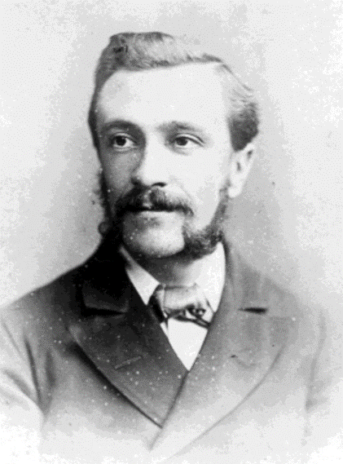
He came from the deanery of Bolton and took over from Rev Lauria. He did not feel it was a big “living” nor an important charge.
He does not seem particularly impressed with the vicarage as it had never been built as a parsonage. He felt the rooms were too small and the place wasn’t compact – too much stone passages was how he described it. Despite that there seem to be advantages – it had a coach house and stable and a paddock of nearly an acre. There were trees at the back and it was out in the country which was an improvement to living on a street and he acknowledges that it became a very dear home for more than 20 years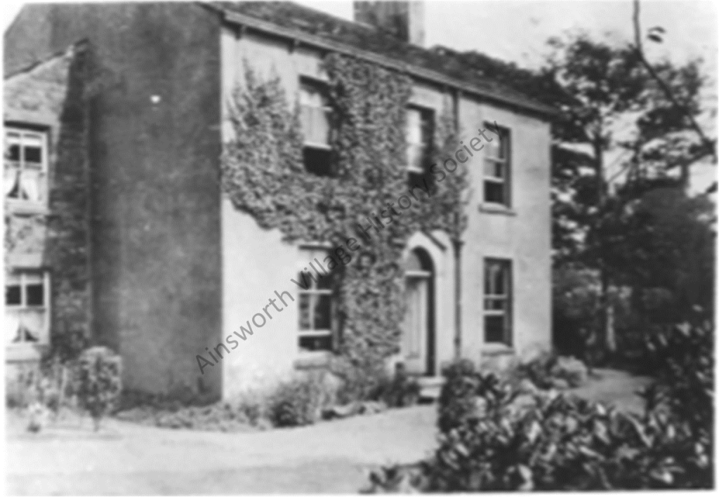
He describes the church - a small very plain rectangular meeting house with galleries, onto which has been added a tower at one end and a small chancel at the other and the furniture – which came from Bury Parish Church. He laments the change in the afternoon service – from 3pm to 6:30pm as it resulted in a drop in attendance. The church school was in need of repair and extension – which resulted in the “New Room”.
The state of the village improved during his time. Transport links along the bottom road were developed. There was little work in the village itself – most workers travelled to the bleachworks and weaving sheds in Breightmet, Bradley Fold, Elton, Radcliffe and near on Bury Road, During his time in the village, a big branch shop of Dobson’s Textile Engineering Works was opened at Bradley Fold, as well as a weaving shed. A new Colliery shaft was sunk near Countess Lane.
(A copy of the full presentation is available on the memories section)

