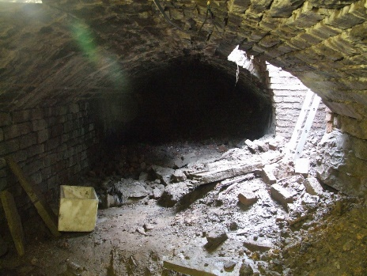
Ainsworth History Society www.ainsworthhistorysociety.org
We again meet on the Second Tuesday of each month from 7:30pm in the upstairs room of Ainsworth Church and Community Hall (on the corner of Bury Old Road and Ainsworth Hall Road). The next meeting is Tuesday 10th May, which will be the last one until September as we will do our history walks in June, July and August. All are welcome.
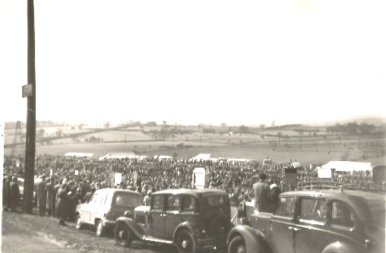
April Meeting:
In the meeting, we saw a number of pictures of Ainsworth from about 1946 to 1953 which Dave C had found and which, with twenty five people attending, some of whom had lived in the village for many years, gave rise to quite a few anecdotes. As some of the pictures were of the area where the races used to be held, we also looked at some photos we had of the Cockey Moor races and watched a short newsreel clip of the race, which showed how well attended it had been.

