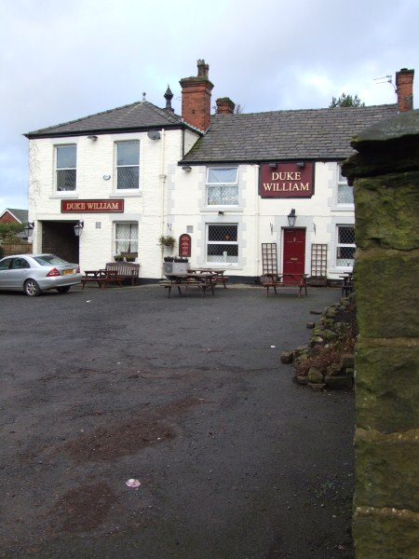
An Historical Walk around Ainsworth
(Start and finish at The Duke William – Ainsworth)

The Duke William Inn dates from the 18th century and
was built on what is now Well Street but was once the
Leeds – Liverpool stage-coach route.

Walk through the tunnel on the left-hand side of The Duke William Inn and pass through the yard to the lane at the back.

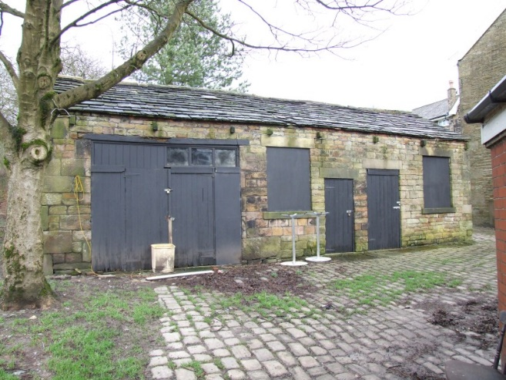

Turn right with the Presbyterian (Unitarian) Chapel on your right hand and the Old Stables, with mounting block, to your left.
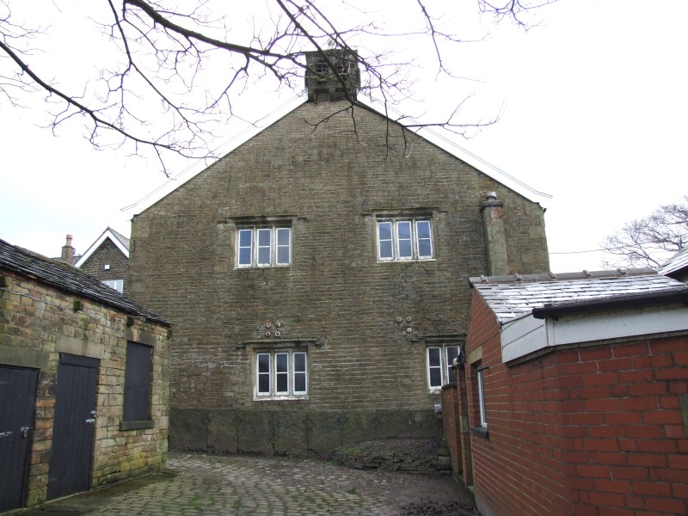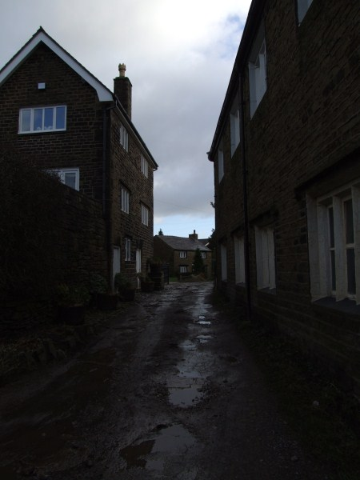

Both buildings are Grade-II listed, both built in the 18th century. The chapel was first built in 1715, enlarged in 1773.

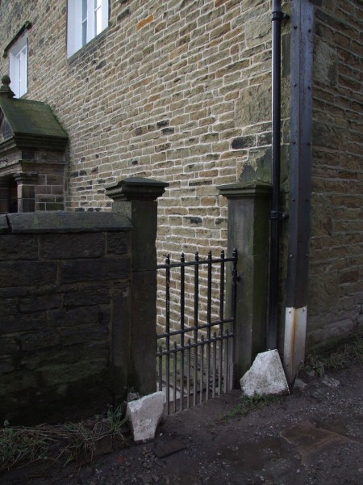
If you follow the chapel wall to the front gates, you can see into the graveyard with its many interesting 18th and 19th century graves.

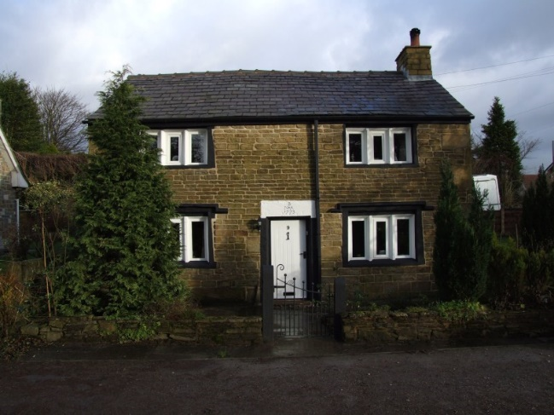

On the left-hand corner of the lane is Hooks Cottage, Oaks Nook, with a date-stone which indicates that it was built by Nathan Brooks (who is buried in the graveyard) in 1773.

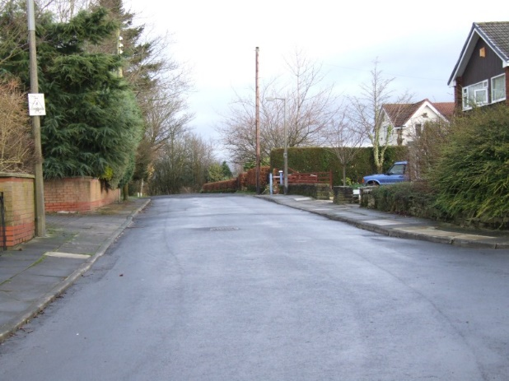

Turn left round Hooks into Knowsley Road and follow the lane past new housing and George’s Wood on the left.

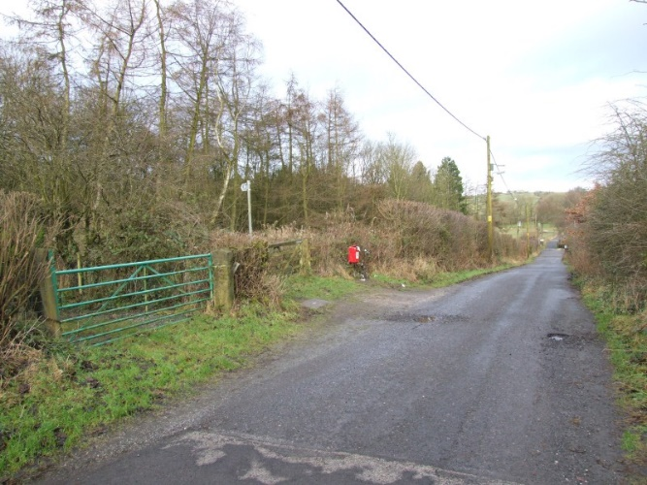

This wood was planted in 1974 by the “Men of the Trees” and is now maintained for the community by the Woodland Trust.

The next part of this walk can be very muddy in wet weather - don't wear your best shoes!
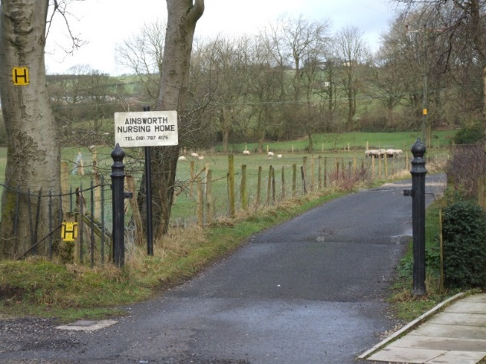

At the junction at the bottom of Knowsley Road, the left-hand lane would take you to Barrack Fold, a 17th-century farm where troops are supposed to have mustered in the Civil War. The Holcombe Hunt point-to-point races were held here from 1921 to 1971. Straight ahead is Ainsworth Nursing Home (Broomfield), until 1986 an isolation hospital for smallpox patients.

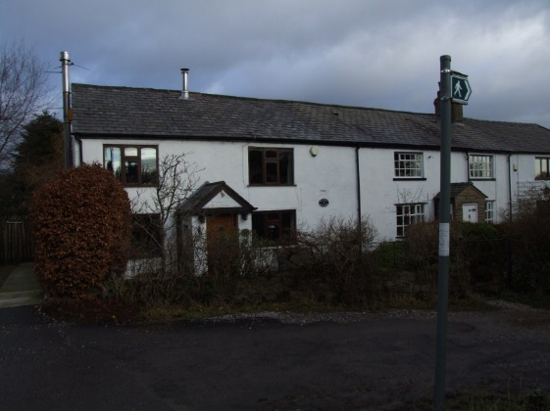

Turn right and follow the lane in front of the weavers’ cottages – reputed to have been lived in by Flemish weavers.

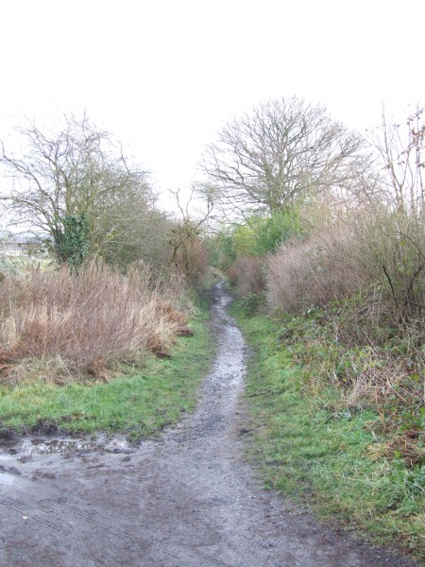
The path narrows through shrubbery – go straight ahead to the stile, which takes you into a field.

Go straight ahead to the left-hand corner of the field where the stile takes you into a lane.

If you turned left here, you would come to the site of Paddock Leach, a 17th-century house which was used as an isolation hospital (smallpox and TB) before Broomfield was built. This house was burned down for public health reasons in 1971, having served local children as a ”haunted house” for many years!

Turn right and follow the path to the junction with the lane to Old Barn Farm. Follow the lane up to the junction with the main village street.

As you walk up, looking out across the fields to your left you will see the Water Tower, erected in the 1940s. As you look across the field to your right as you reach the top of the lane, you will see Moorside Mill, dating from the 1840s and used for a variety of manufacturing purposes over the years, including cotton fabrics, wooden packing cases and glues.
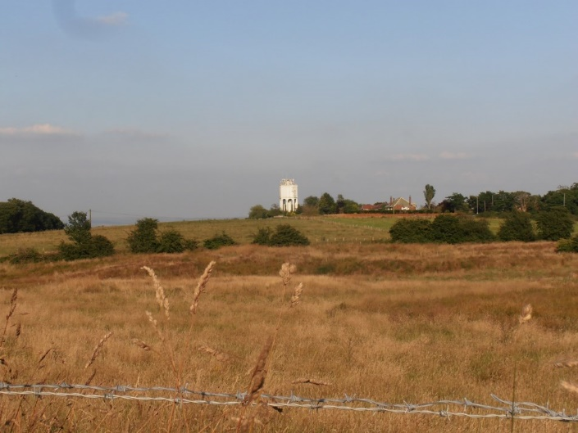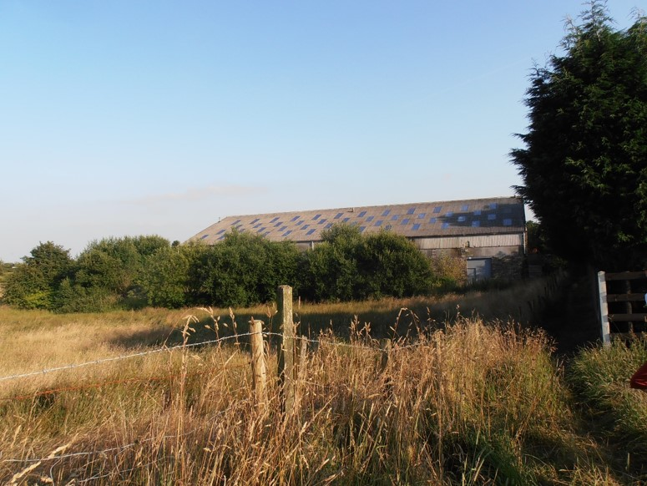

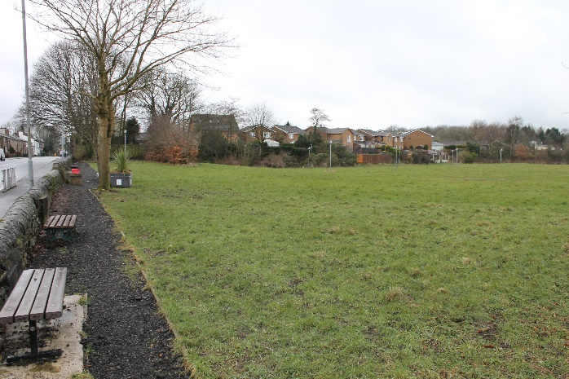
Turn right at the top of the lane and walk up through the village. On your right on your way up the hill you will pass the “Delph”, an open space that was once a quarry. The quarry flooded and was an open stretch of water until the 1960s, when it was filled in with gravestones from St Thomas’s churchyard in Radcliffe.

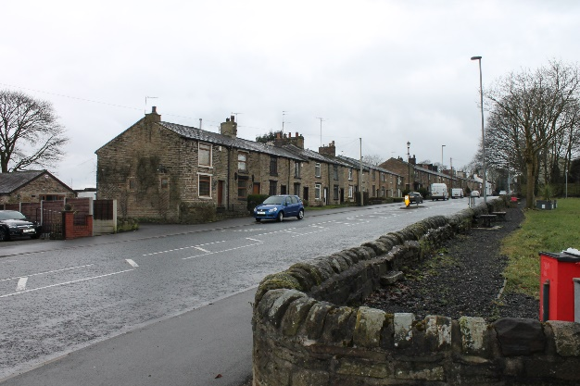
The cottages opposite the Delph are “club houses”, built around 1830 by workers paying into a club fund. Some of these houses were originally “back-to-back” houses. Continue along what was, until the 1990s, a busy village street with many shops including newsagent, green-grocer, hairdresser, hardware store, electrical shop, chemist and, in the large terrace facing the Old White Horse pub, a Co-op, founded in 1864, with its own butcher’s shop. Remaining in the village are a fish and chip shop, post office and, reputedly, one of the smallest branch libraries in Britain.

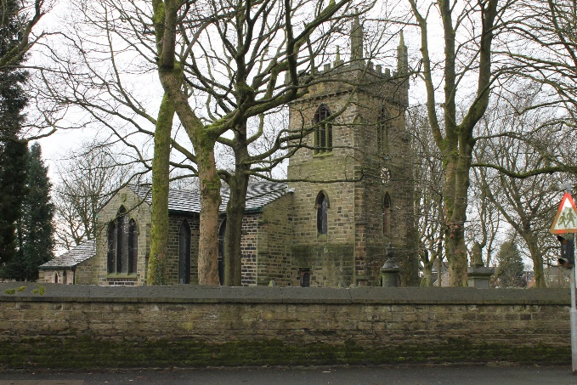
Cross the main road at the traffic island opposite Number 23 and turn left into Bradley Fold Road. Cross the road and pass the terrace on your right. Turn right into a side path and you will find the back gate of the graveyard of Christ Church. There has been a church here at least since 1515 when it was mentioned in a court case - the current building dates from the early 1830s.

Follow the path round the church and head for the lych gate where you will find yourself back on the village street. Just inside the lych gate are the remains of the village stocks – these date from 1753.

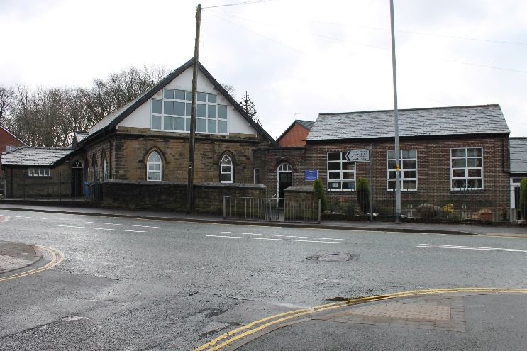
Turn left and pass Holly Bank, built in 1832, and a 20th-century house which was formerly the vicarage. Cross Ainsworth Hall Road to the Parish Hall, formerly Christ Church C of E Primary School. Built in 1838, this building served as a school for local children until 1983 and the small yard around the building served as their playground. The school has relocated to a modern building behind Stanley Terrace on the other side of the village street, and the children now have a whole field to play in.

Opposite the Parish Hall is the village recreation ground, donated, as inscribed on the gate posts, to the community by Henry Whitehead of Haslam Hey in 1902.
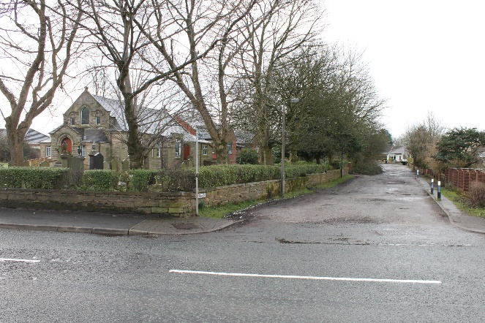
Continue along the village street and you will arrive at the Methodist Church. There has been a Methodist New Connexion church in the village since 1846 – the present building was finished in 1892. It is believed that the older church was where there is now a white bungalow on the opposite side of the road. Prior to that, members of the New Connexion used to meet in a cottage in Delph Lane.

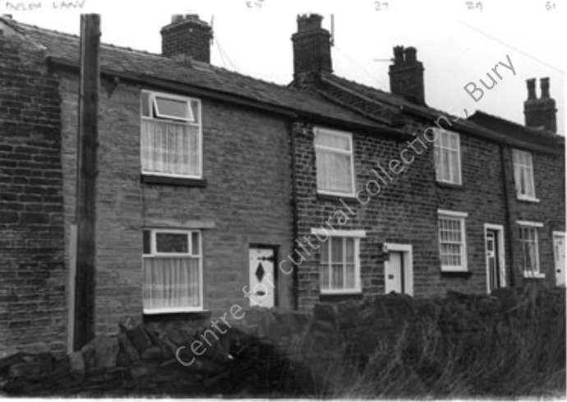
Cross the main road and bear right into Delph Lane, walking up to the stone cottages at the end. Just before the cottages, you cross the old Leeds – Liverpool coaching road with the site of the Anchor coaching inn in the field to your left, behind the semi-detached houses. Follow the public footpath to the right of the cottages – this is Hey Club Row, more houses erected by workers paying into a club fund.

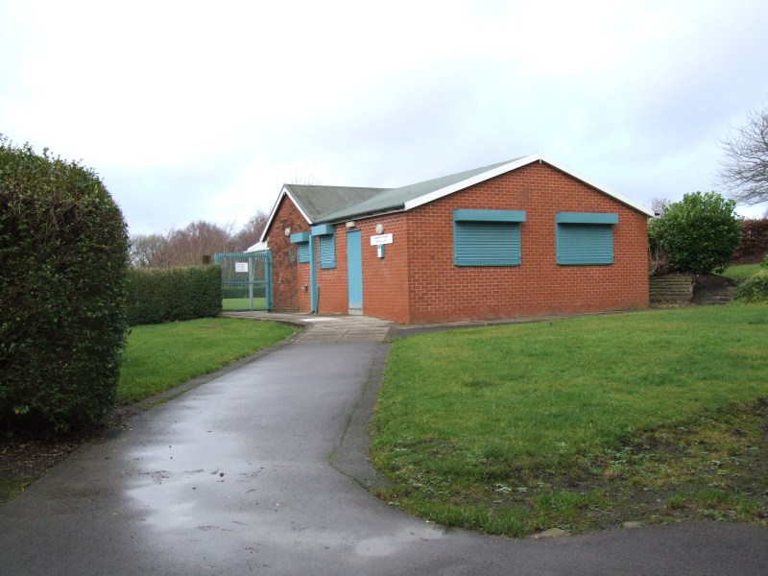

Pass through the narrow gate at the end of the path – the land opposite was the site of another “delph” or quarry. Turn right here and follow the narrow footpath past the new primary school and the bowling green over the wall on your right hand side. After the bowling green, bear right into the yard behind The Duke William Inn.

The Duke William Inn is a Grade-II listed building dating from the 18th century. Reputedly haunted, it has recently acquired a reputation for excellent food and drink and is an ideal finishing point for this short historical walk.

Dave Clegg

