Electric lighting

by David Earnshaw
One thing that is quite significant that came back to me is that Ainsworth was one of the first villages to have electric street lights. I don't think they ever had gas lit streets (*see below). The electricity was from the power station in Radcliffe named LEP Co Lancashire Electric Power Co and the Ainsworth substation was a large brick building of high standard. It is still in existence and can be located at the bottom of a back garden on Bury Old Road.
I found a reference as to the Earl of Wilton allowing the LEP Co to erect posts to carry the cables and lights. I remember the one on the corner of the recreation ground was a wooden telegraph type pole with a shaped copper top. The light was on a bracket screwed on the pole - the same type was on Delph Lane at the corner of the stone wall that leads up to Meadow Cottage. This particular one they forgot to put the copper cap on and Councillor Ellis Albert Walker who lived on Delph Lane complained and insisted they returned to fit the cap.
* It seems that there may have been some gas street lights - as shown by this photo (which is said to be of a gas lamp post) at the corner of the weavers cottages on Knowsley Road. However, it may have been lighting to the isolation hospital and not street lighting
* David has since been in contact to say he was wrong about the lack of gas street lights. He writes: "A lady of 101 who was born in Ainsworth has confirmed Gas lighting on School Side she was born at Kiln Clough Farm and remembers the lamp lighter coming round"
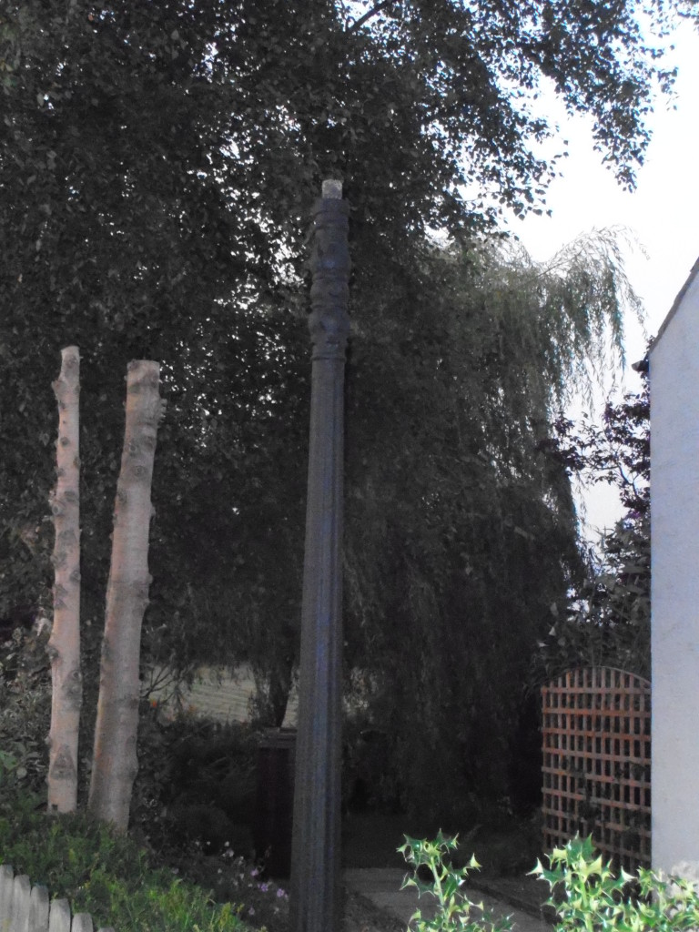
(if you have any further information on the street lighting in Ainsworth, please let us know)

