Dearden fold farm

Metal Detecting

Transcript of part of letter dated 9th April 2013

Thought I would bring you up to date on my metal detector survey of the field directly behind your house. Have only covered a quarter of this field so far and had excellent results in terms of the number of finds. Have recovered nearly 50 coins, from KGIII thought to Victorian period – Edward VIII – George V and VI and to modern day decimal. Sadly, most of the coins are badly degraded, which is due to the very acid nature of this soil. Most of them are copper and bronze alloys which are prone to degradation. Not found any gold or silver (yet!). I carry the coins with me when on site – I’ll let you have a look whenever you want
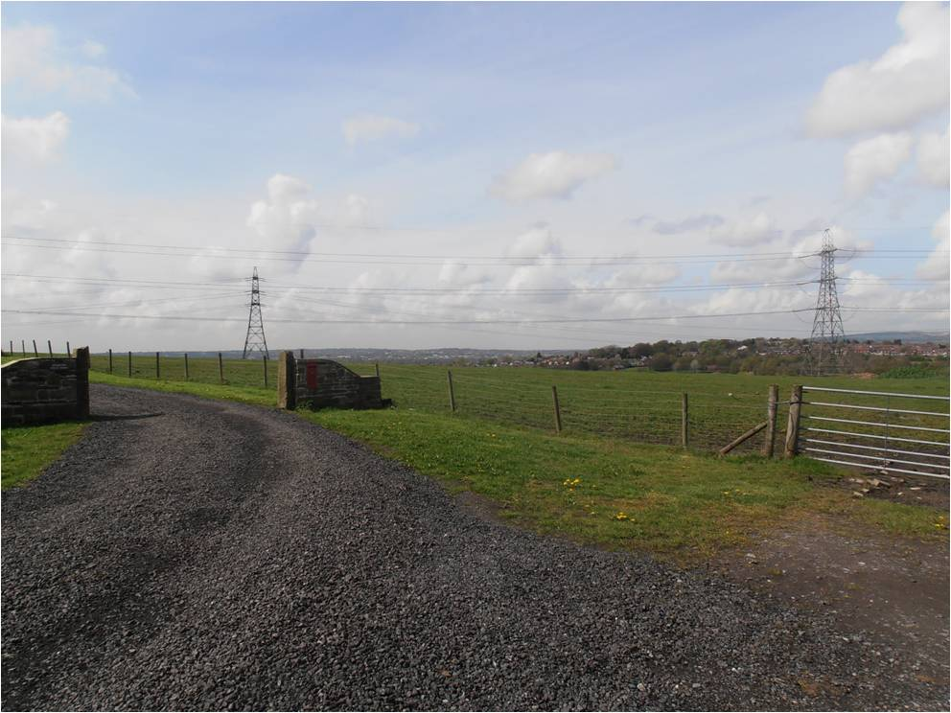
There are a lot of iron finds in this field too … mainly nails and ancient horseshoes. Kept a few of these to decorate my veggie patch pergola, left the others in situ. Just let me know if you want these digging out in future. As well as iron finds – there have been one or two interesting lead cloth seals and a little lead sculpted ox head (probably Victorian). There are plenty of lumps of iron slag all over the surveyed area and nuts & bolts of various sizes. It seems that the field has been subject to “midden” dumping in the distant past, fairly common in Victorian times. Lots of broken pottery and clay pipe stems, as well as broken glass.

The decimal coin finds all seem to be late 60’s early 70’s – do you remember the field being used for a fete or Agricultural Show in that period? That would explain these coin finds. As to the other coin finds, my guess is the field has been used occasionally for public gatherings over a span of 300+ years or so. Perhaps you can shed some light on this?

